Define the following:
water cycle:

evaporation:

condensation:

precipitation:

transpiration:

weather:

climate:
air pressure:

wind:

tropical climate zone:

temperate climate zone:

desert climate zone:

mountain climate zone:

polar climate zone:

jett stream:

gulf stream:

atmosphere:

troposphere:

front:

equator:

Answer the Following:
- Describe these 2 reasons earth is able to maintain a temperature that maintains life:
  - Atmosphere:

  - Direct sunlight, indirect sunlight, and Earth’s tilted axis:
- Why does wind end up blowing in circles?

- What creates weather?

- What creates a desert climate? Why does a desert not receive much precipitation?

- Why is Salt Lake City colder than San Francisco in the winter, but hotter during the summer?

- What is the latitude of Salt Lake City? What is our climate and why?

- In which direction do prevailing winds usually move across Utah and the United States?

- How do Mountains affect weather?

- What creates ocean currents and how do they effect the climate of land around them?

- Why is Massachusetts colder than Washington in the winter but warmer in the Summer?

- What temperatures cause more water evaporation?

12: Draw a model of how air currents move between the equator and 30 degrees latitude (both north and south of the equator:
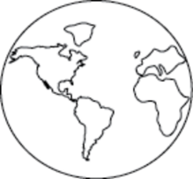

What creates this motion of air currents?

What causes wind to move from west to east or east to west?

Why would there be more precipitation in coastal areas with warmer ocean currents?

